Technical Study

The core of project G – Dump is the specialized dustbin that our team designed inclusive of all circuitry. The dustbin’s exoskeleton is a plastic foot pedal container which opens and closes depending on whether the pedal is pressed. The inner circuitry of the dustbin keeps track of the number of customers and generates a unique code according to which prize money will be distributed.

The main components of the dustbin are:-

1. PCB
2. Resistors
3. LDR
4. LCD
5. Atmega328
6. Laser diode

DESCRIPTION OF COMPONENTS:

# *1. Arduino*

**Arduino** is an open source computer hardware and software company, project, and user community that designs and manufactures single-board microcontrollers and microcontroller kits for building digital devices and interactive objects that can sense and control objects in the physical and digital world. The project's products are distributed as open-source hardware and software, which are licensed under the GNU Lesser General Public License (LGPL) or the GNU General Public License (GPL), permitting the manufacture of Arduino boards and software distribution by anyone.

 Arduino board designs use a variety of microprocessors and controllers. The boards are equipped with sets of digital and analog input/output (I/O) pins that may be interfaced to various expansion boards or Breadboards (*shields*) and other circuits. The boards feature serial communications interfaces, including Universal Serial Bus (USB) on some models, which are also used for loading programs from personal computers. The microcontrollers are typically programmed using a dialect of features from the programming languages C and C++. In addition to using traditional compiler tool chains, the Arduino project provides an integrated development environment (IDE) based on the Processing language project

TWO MAIN PARTS OF ARDUINO:-

1. Hardware

Most Arduino boards consist of an Atmel 8-bit AVR microcontroller (ATmega8, ATmega168, ATmega328, ATmega1280, ATmega2560) with varying amounts of flash memory, pins, and features. The 32-bit Arduino Due, based on the Atmel SAM3X8E was introduced in 2012. The boards use single or double-row pins or female headers that facilitate connections for programming and incorporation into other circuits. These may connect with add-on modules termed *shields*. Multiple and possibly stacked shields may be individually addressable via an I²C serial bus. Most boards include a 5 V linear regulator and a 16 MHz crystal oscillator or ceramic resonator. Some designs, such as the LilyPad, run at 8 MHz and dispense with the onboard voltage regulator due to specific form-factor restrictions.

Arduino microcontrollers are pre-programmed with a boot loader that simplifies uploading of programs to the on-chip flash memory. The default bootloader of the Arduino UNO is the optiboot bootloader. Boards are loaded with program code via a serial connection to another computer. Some serial Arduino boards contain a level shifter circuit to convert between RS-232 logic levels and transistor–transistor logic (TTL) level signals. Current Arduino boards are programmed via Universal Serial Bus (USB), implemented using USB-to-serial adapter chips such as the FTDI FT232. Some boards, such as later-model Uno boards, substitute the FTDI chip with a separate AVR chip containing USB-to-serial firmware, which is reprogrammable via its own ICSP header.

The Arduino board exposes most of the microcontroller's I/O pins for use by other circuits. The *Diecimila, Duemilanove*, and current *Uno* provide 14 digital I/O pins, six of which can produce pulse-width modulated signals, and six analog inputs, which can also be used as six digital I/O pins. These pins are on the top of the board, via female 0.1-inch (2.54 mm) headers. Several plug-in application shields are also commercially available.

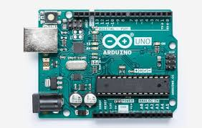

1. Software

The Arduino integrated development environment (IDE) is a cross-platform application (for Windows, macOS, Linux) that is written in the programming language Java. It originated from the IDE for the languages *Processing* and *Wiring*. It includes a code editor with features such as text cutting and pasting, searching and replacing text, automatic indenting, brace matching, and syntax highlighting, and provides simple *one-click* mechanisms to compile and upload programs to an Arduino board. It also contains a message area, a text console, a toolbar with buttons for common functions and a hierarchy of operation menus.

The Arduino IDE supports the languages C and C++ using special rules of code structuring. The Arduino IDE supplies a software library from the Wiring project, which provides many common input and output procedures. User-written code only requires two basic functions, for starting the sketch and the main program loop, that are compiled and linked with a program stub *main()* into an executable cyclic executive program with the GNU tool chain, also included with the IDE distribution. The Arduino IDE employs the program *avrdude* to convert the executable code into a text file in hexadecimal encoding that is loaded into the Arduino board by a loader program in the board's firmware.

# *2. Laser Diode*

A **laser diode**, (**LD**), **injection laser diode** (**ILD**), or **diode laser** is a semiconductor device similar to a light-emitting diode in which the laser beam is created at the diode's junction. Laser diodes are the most common type of lasers produced, with a wide range of uses that include fiber optic communications, barcode readers, laser pointers, CD/DVD/Blu-ray disc reading/recording, laser printing, laser scanning and light beam illumination.

## Theory of operation

A laser diode is electrically a PIN diode. The active region of the laser diode is in the intrinsic (I) region and the carriers (electrons and holes) are pumped into that region from the N and P regions respectively. While initial diode laser research was conducted on simple P-N diodes, all modern lasers use the double-hetero-structure implementation, where the carriers and the photons are confined in order to maximize their chances for recombination and light generation. Unlike a regular diode, the goal for a laser diode is to recombine all carriers in the (I) region, and produce light. Thus, laser diodes are fabricated using direct band-gap semiconductors. The laser diode epitaxial structure is grown using one of the crystal growth techniques, usually starting from an N doped substrate, and growing the (I) doped active layer, followed by the P doped cladding, and a contact layer. The active layer most often consists of quantum wells, which provide lower threshold current and higher efficiency.

Laser diodes form a subset of the larger classification of semiconductor *p*-*n* junction diodes. Forward electrical bias across the laser diode causes the two species of charge carrier – holes and electrons – to be "injected" from opposite sides of the *p*-*n* junction into the depletion region. Holes are injected from the *p*-doped, and electrons from the *n*-doped, semiconductor. (A depletion region, devoid of any charge carriers, forms as a result of the difference in electrical potential between *n*- and *p*-type semiconductors wherever they are in physical contact.) Due to the use of charge injection in powering most diode lasers, this class of lasers is sometimes termed "injection lasers “or” injection laser diode" (ILD). As diode lasers are semiconductor devices, they may also be classified as semiconductor lasers. Either designation distinguishes diode lasers from solid-state lasers.

## Uses

Laser diodes are numerically the most common laser type, with 2004 sales of approximately 733 million units, as compared to 131,000 of other types of lasers.

Laser diodes find wide use in telecommunication as easily modulated and easily coupled light sources for fiber optics communication. They are used in various measuring instruments, such as rangefinders. Another common use is in barcode readers. Visible lasers, typically red but later also green, are common as laser pointers. Both low and high-power diodes are used extensively in the printing industry both as light sources for scanning (input) of images and for very high-speed and high-resolution printing plate (output) manufacturing. Infrared and red laser diodes are common in CD players, CD-ROMs and DVD technology. Violet lasers are used in HD DVD and Blu-ray technology. Diode lasers have also found many applications in laser absorption spectrometry (LAS) for high-speed, low-cost assessment or monitoring of the concentration of various species in gas phase. High-power laser diodes are used in industrial applications such as heat treating, cladding, seam welding and for pumping other lasers, such as diode-pumped solid-state lasers.

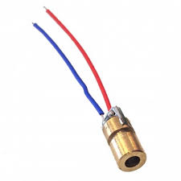

# 3. Pedal Bin

A **pedal bin** is a container with a lid operated by a foot pedal. Lillian Moller Gilbreth (an industrial engineer and efficiency expert as well as mother of twelve) invented the pedal bin in the 1920s for the disposal of kitchen waste. The footpedal enables the user to open the lid without touching it with their hands.

It is made of durable HDPE which makes it light and strong.

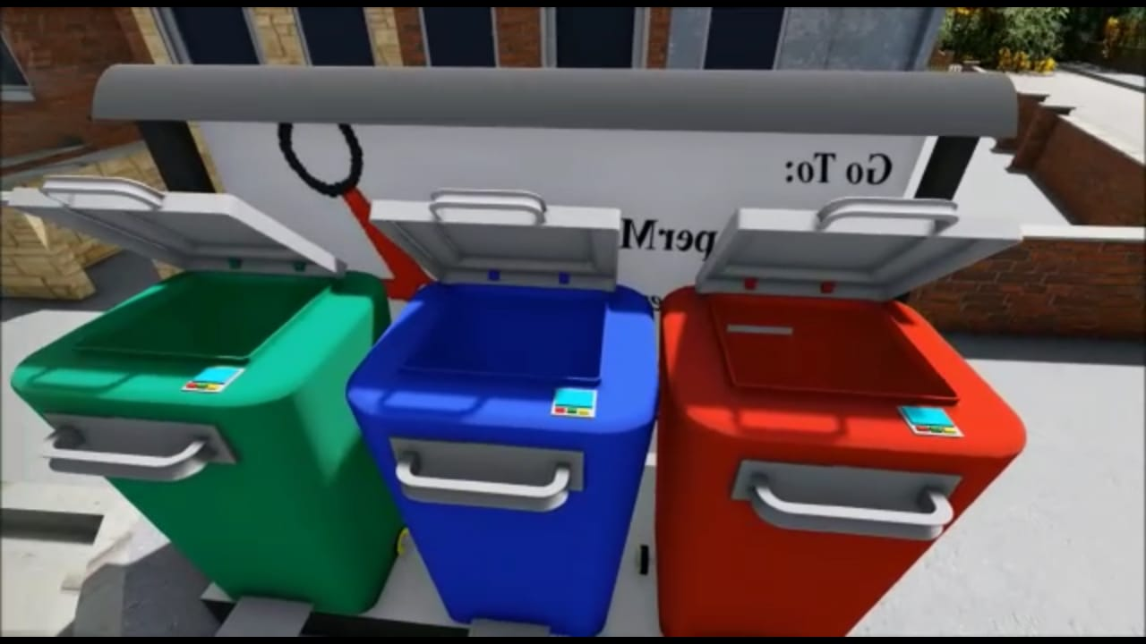

# High-density polyethylene

**High-density polyethylene** (**HDPE**) or **polyethylene high-density** (**PEHD**) is a polyethylene thermoplastic made from petroleum. It is sometimes called "alkathene" or "polythene" when used for pipes. With a high strength-to-density ratio, HDPE is used in the production of plastic bottles, corrosion-resistant piping, geomembranes, and plastic lumber. HDPE is commonly recycled, and has the number "2" as its resin identification code.

In 2007, the global HDPE market reached a volume of more than 30 million tons.

## Properties of HDPE

HDPE is known for its large strength to density ratio. The density of HDPE can range from 930 to 970 kg/m3. Although the density of HDPE is only marginally higher than that of low-density polyethylene, HDPE has little branching, giving it stronger intermolecular forces and tensile strength than LDPE. The difference in strength exceeds the difference in density, giving HDPE a higher specific strength. It is also harder and more opaque and can withstand somewhat higher temperatures (120 °C/ 248 °F for short periods). High-density polyethylene, unlike polypropylene, cannot withstand normally required autoclaving conditions.

# 4. LCD Screen

A **liquid-crystal display** (**LCD**) is a flat-panel display or other electronically modulated optical device that uses the light-modulating properties of liquid crystals. Liquid crystals do not emit light directly, instead using a backlight or reflector to produce images in color or monochrome. LCDs are available to display arbitrary images (as in a general-purpose computer display) or fixed images with low information content, which can be displayed or hidden, such as preset words, digits, and seven-segment displays, as in a digital clock. They use the same basic technology, except that arbitrary images are made up of a large number of small pixels, while other displays have larger elements.

An LCD panel today has over six million pixels, and they are all individually powered by a wire network embedded in the screen. The fine wires, or pathways, form a grid with vertical wires across the whole screen on one side of the screen and horizontal wires across the whole screen on the other side of the screen. To this grid each pixel has a positive connection on one side and a negative connection on the other side. So the total amount of wires needed is 3 x 1920 going vertically and 1080 going horizontally for a total of 6840 wires horizontally and vertically. That's three for red, green and blue and 1920 columns of pixels for each color for a total of 5760 wires going vertically and 1080 rows of wires going horizontally. The LCD panel is powered by LCD drivers that are carefully matched up with the edge of the LCD panel at the factory level. LCD panels typically use thinly-coated metallic conductive pathways on a glass substrate to form the cell circuitry to operate the panel. It is usually not possible to use soldering techniques to directly connect the panel to a separate copper-etched circuit board. Instead, interfacing is accomplished using either adhesive plastic ribbon with conductive traces glued to the edges of the LCD panel, or with an elastomeric connector, which is a strip of rubber or silicone with alternating layers of conductive and insulating pathways, pressed between contact pads on the LCD and mating contact pads on a circuit board.

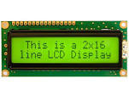

# 5. Photoresistor

A **photoresistor** (or **light-dependent resistor**, **LDR**, or **photo-conductive cell**) is a light-controlled variable resistor. The resistance of a photoresistor decreases with increasing incident light intensity; in other words, it exhibits photoconductivity. A photoresistor can be applied in light-sensitive detector circuits, and light-activated and dark-activated switching circuits.

A photoresistor is made of a high resistance semiconductor. In the dark, a photoresistor can have a resistance as high as several megohms (MΩ), while in the light, a photoresistor can have a resistance as low as a few hundred ohms. If incident light on a photoresistor exceeds a certain frequency, photons absorbed by the semiconductor give bound electrons enough energy to jump into the conduction band. The resulting free electrons (and their hole partners) conduct electricity, thereby lowering resistance. The resistance range and sensitivity of a photoresistor can substantially differ among dissimilar devices. Moreover, unique photoresistors may react substantially differently to photons within certain wavelength bands.

WORKING

When the dustbin lid is opened, it triggers the laser and the Arduino/development board. The uploaded program on the board checks for interrupt and when it finds one it generates a code, according to a procedure fed into the main code, which is to be entered into the Gdump app. All such codes are recorded in our database and specified prizes are distributed accordingly in 24 hr.. 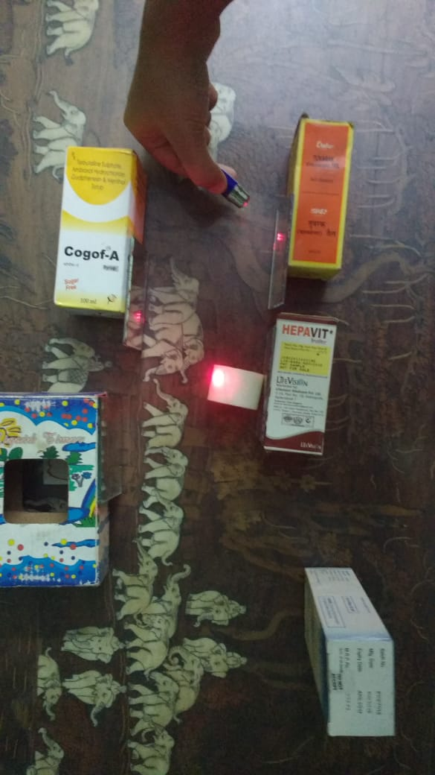

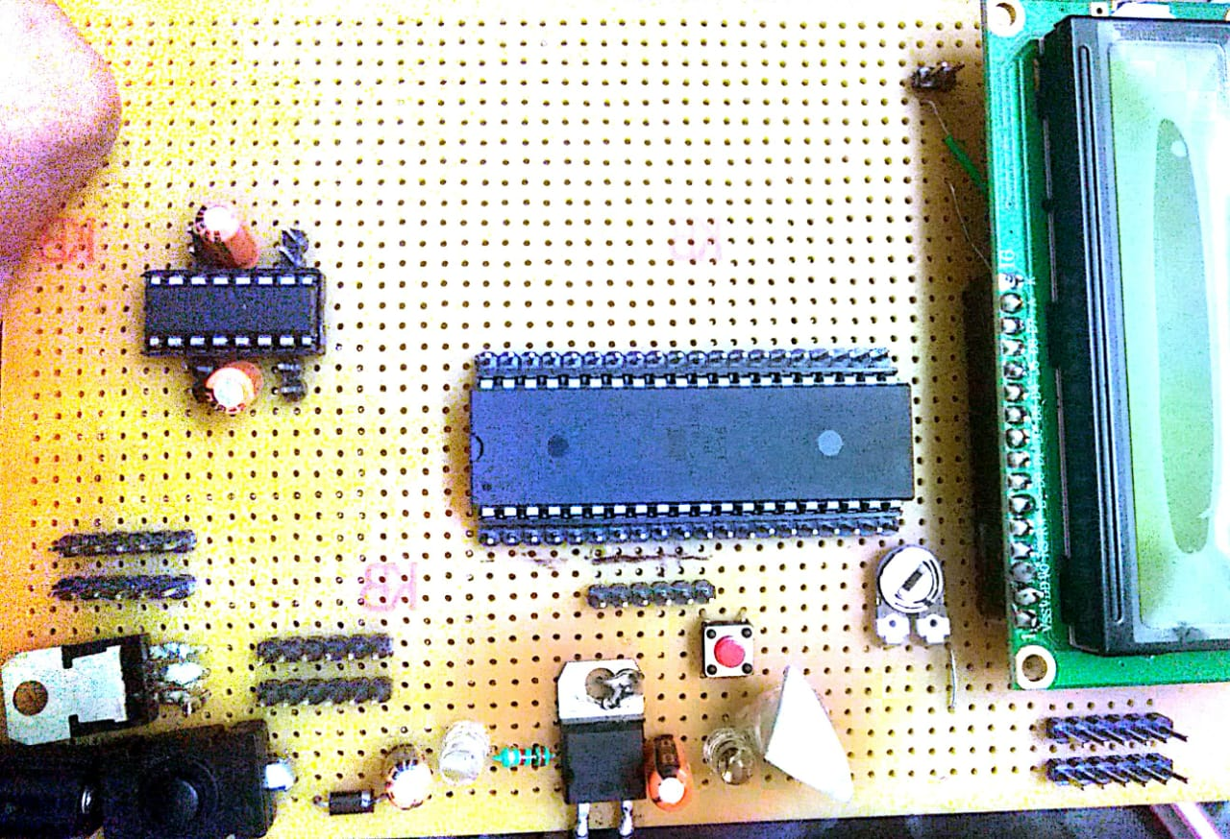

**PART OF G DUMP CIRCUIT**

# The Gdump App

The app has been designed with the purpose of safe communication between the user and our team in relation to the distribution of prizes. The code generation process is abstract enough to not be hacked easily and prizes will be distributed in 24 hours time.

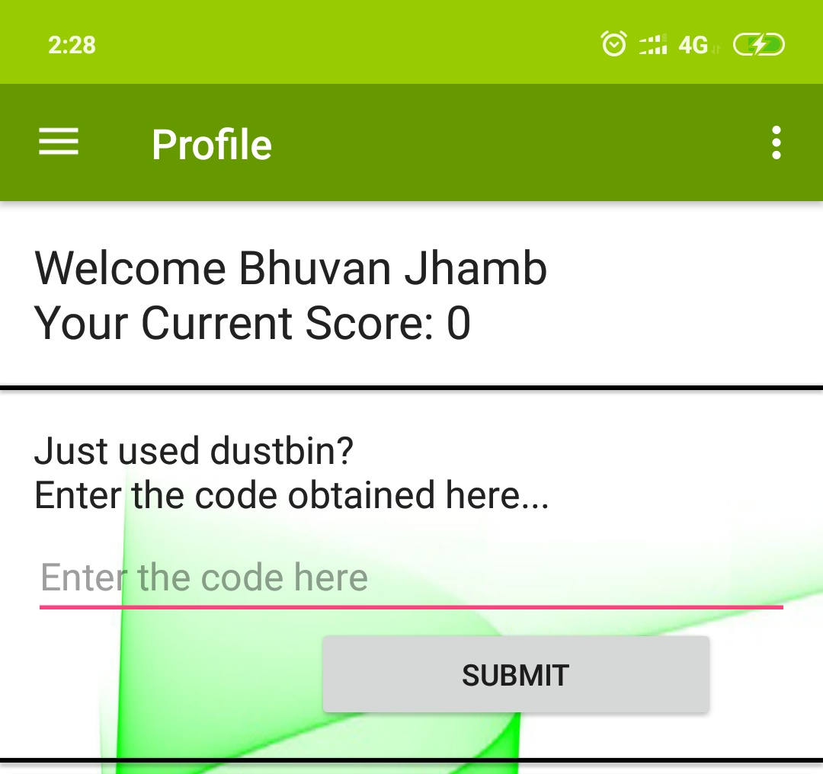**G DUMP APP**

### Structure

The dustbin consists of 3 pedal bins with their own circuitry. One for plastic waste, one for biodegradable waste and another for wet waste. The bins can be differentiated based on the differing color schemes.

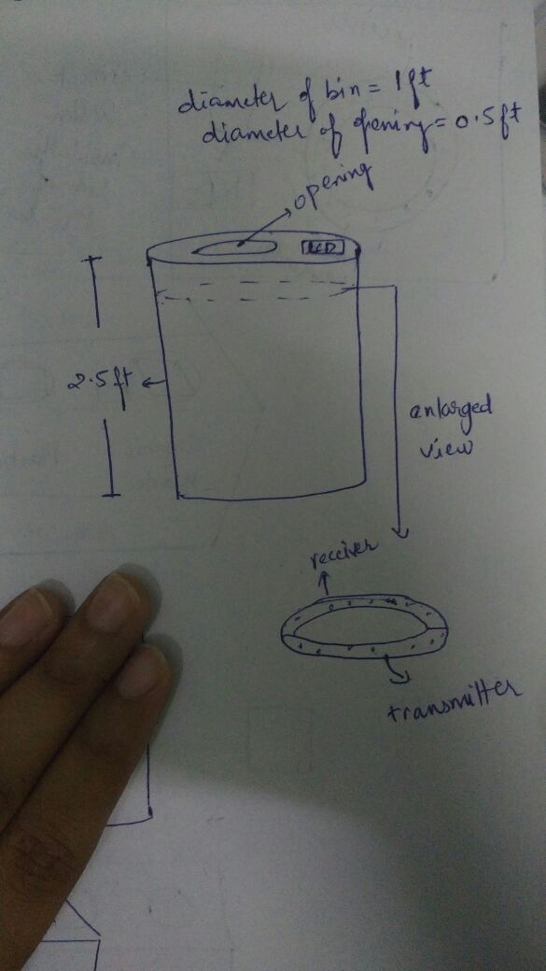

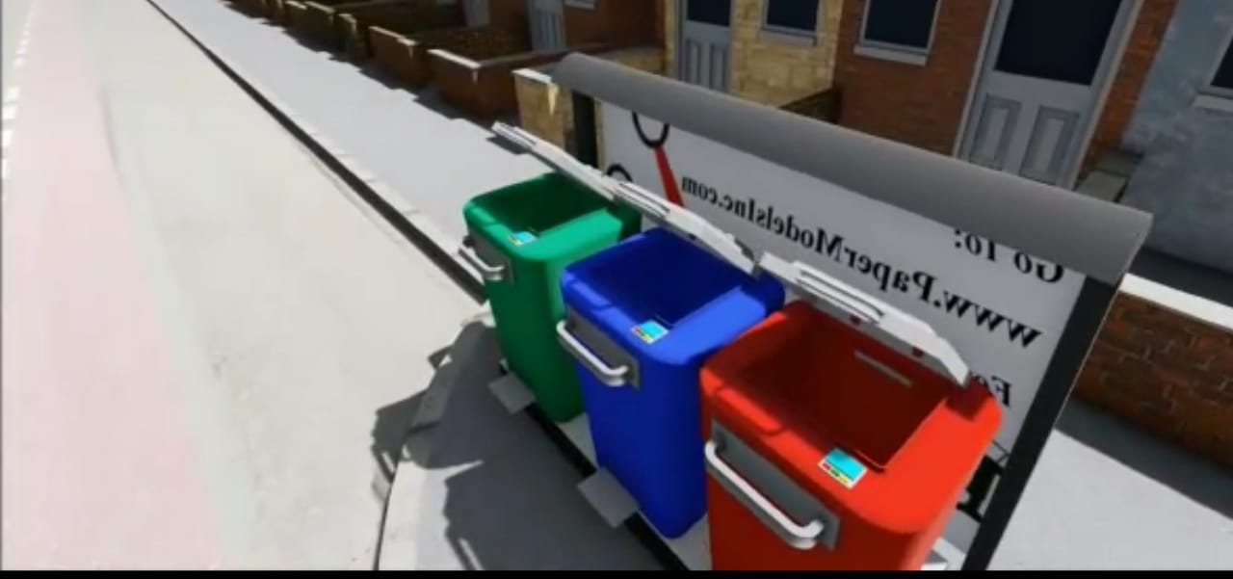

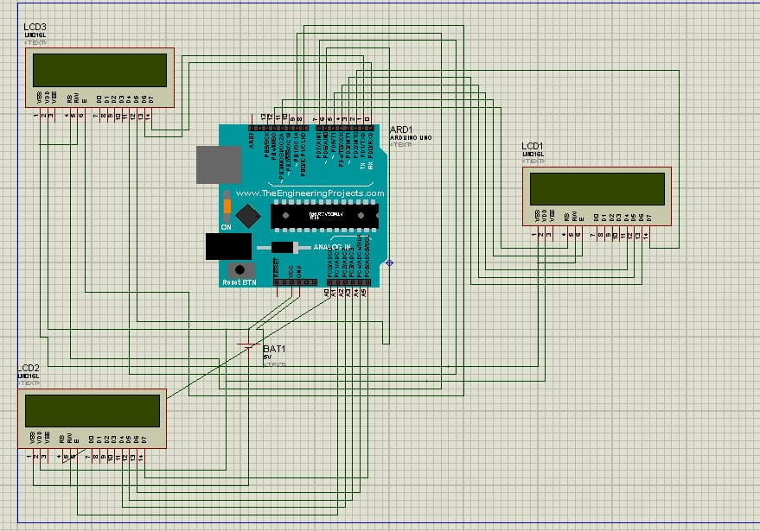

**PART OF G DUMP CIRCUIT**